# PeopleSafe - Appeals

[Requesting an Appeal](#_Toc160542949)

[Checking the Status of an Appeal](#_Toc160542950)

[Urgent (Life Threatening) Appeals RM Task](#_Toc160542951)

[External Review RM Task](#_Toc160542952)

[Appeal Denial Member Requesting Clinical Guidelines](#_Toc160542953)

[Turnaround Time](#_Toc160542954)

[Alternatives](#_Toc160542955)

[Frequently Asked Questions (FAQ)](#_Toc160542956)

[Standard Appeal Approval Member Letter Sample](#_Toc160542957)

[Standard Appeal Denial Member Letter Sample](#_Toc160542958)

[Related Documents](#_Toc160542959)

**Description:** Procedures for an appeal, which is a dispute to have a product covered with member’s prescription benefit when it normally is not. Anyone can file for an appeal, and it doesn’t have to be done by a provider.

 This document applies to Commercial clients **ONLY**, not MED D or EGWP. Refer to [MED D - Coverage Determinations and Redeterminations (Appeals) Landing Page (004825)](https://thesource.cvshealth.com/nuxeo/thesource/#!/view?docid=1e7d7ad7-e1c1-4fa1-8258-215a1c0ff32b) for further guidance.

|  |
| --- |
| Requesting an Appeal |

An Appeal is a request to reprocess a denied review. Plan specific steps to request an appeal are provided to the member and prescriber within the denial letter.

 **Important Reminders for PBM managed Appeals:**

* Appeals should not be offered until all other alternatives have been explored. Run a Test Claim and explore alternatives listed.
* To request an Appeal, there must be at least one denial of a request for coverage on file. If there is no denial on file, an Appeal cannot be requested. Refer to [Prior Authorization, Exceptions, Appeals Guide (063978)](https://thesource.cvshealth.com/nuxeo/thesource/#!/view?docid=657ddfe3-27d1-4a21-8f51-8cbd3961001c).Appeal must be submitted within 60 days of the denial.
* Do **not** transfer the member to the Appeal Department.
* Do **not** provide Appeal Department phone number to the member; the member should contact their Provider for all Appeal updates regarding denial reasons or pending statuses if not viewable in Compass.
* A **fully authorized** Third-Party caller may initiate an Appeal. Third Party callers must provide the information for the Appeal process and also written consent from the member for Provider’s office to file an appeal on member’s behalf.

**Notes:**

* Any letter after the PA number identifies this as an appeal. Letters may vary based on specifics of the appeal.
* **Specialty Medications** warm transfer the member to Specialty Customer Care (**1-800-237-2767**). If the Provider’s office is calling about Specialty medication for Prior Authorization/Appeal, warm transfer to Specialty Department (**1-866-814-5506**).
* Discount Cards do not have Prior Authorization or Appeals.
*  If Member is requesting a copy of an Appeal Approval/Denial letter and our PBM handles the Appeals, contact the [Prior Authorization Department (004378)](https://thesource.cvshealth.com/nuxeo/thesource/#!/view?docid=f22eb77e-4033-4ad9-9afb-fc262f29faad) for the copy.

Perform the steps below:

|  |  |  |  |  |
| --- | --- | --- | --- | --- |
| **Step** | **Action** | | | |
| **1** | Access PeopleSafe and review the rejection or Test Claim settlement codes. | | | |
| **2** | Review the settlement codes, view comments, view problems, and view notepad screens to determine the reason for the rejection.   * Educate the member about the rejection, using [Test Claims (004573)](https://thesource.cvshealth.com/nuxeo/thesource/#!/view?docid=59c4e7fa-4a87-43c4-89cd-5d4f8c6c3421) as needed to clarify coverage for that drug. | | | |
| **3** | Review PeopleSafe to verify the there is a denied Prior Authorization, Clinical Exception, or Non-Clinical Exception request within 60 days.  Refer to [Prior Authorization, Exceptions, Appeals Guide (063978)](https://thesource.cvshealth.com/nuxeo/thesource/" \l "!/view?docid=657ddfe3-27d1-4a21-8f51-8cbd3961001c" \t "_blank).   * You may also run a [test claim (004573)](https://thesource.cvshealth.com/nuxeo/thesource/" \l "!/view?docid=59c4e7fa-4a87-43c4-89cd-5d4f8c6c3421" \t "_blank) to see if a Prior Authorization or Clinical Exception is needed. * You may also look at [Frequently Asked Question](#_Frequently_Asked_Questions) section Q2 for wording that may be seen in the test claim.   **Note:**Any letter after the PA number identifies this as an appeal. Letters may vary based on specifics of the appeal. | | | |
| **Description** | | **Example** | |
| Prior Authorization needed rejection | |  | |
| Clinical Exception needed rejection | |  | |
| Non-Clinical Exception needed (MAC/DAW Cost Difference) | |  | |
| **4** | Advise the member of the denial reason provided in PeopleSafe and offer to search for alternatives.   I absolutely understand that obtaining your medication is important to you. The <Prior Authorization/Exception> has been denied. You will be mailed a copy of the denial letter. You may choose to pay out of pocket for the medication or discuss alternative medications with your provider. If you’d like, I’ll be happy to search for potentially cost-saving alternatives that may not require an approval request.  **Note:** If the denial was due to missing information, or the caller states information was missing or may now be available that was not before, assist member with a second Prior Authorization or Exception request, refer to [Prior Authorization, Exceptions, Appeals Guide (063978)](https://thesource.cvshealth.com/nuxeo/thesource/#!/view?docid=657ddfe3-27d1-4a21-8f51-8cbd3961001c). | | | |
| **5** | Refer to the CIF to determine if our PBM handles appeals for the member.   Do **not** transfer the member to Appeals department.   Do **not** provide their phone number to the member.  If the PA or Appeal updates are not viewable in PeopleSafe, the member should contact their provider for updates regarding denial reasons or pending statuses. | | | |
| **If…** | | **Then…** | |
| Provider is calling, our PBM handles appeals, and is asking for a more thorough explanation as to why the request was denied | | Review the reason for denial with the prescriber by viewing the denial reason in PeopleSafe.    After reviewing denial reason, if more information is required, contact the PA department using the number from the reject, if there is no phone number in the reject, you may call **1-800-294-5979**.  **Notes:**   * Appeals can be started as soon as a denial is received, however, in most cases they must be requested within 60 days of the original denial. The caller may refer to the denial letter for more specific information for the specific plan. * If a Prior Authorization or Clinical Exception is denied due to information provided being incomplete or inaccurate, the provider may be **warm transferred** to the PA department at **1-800-294-5979** to correct or update the information without moving forward into the Appeal process. * Advise the provider of the Appeals RxClaim fax (**1-866-689-3092**) to send a Letter of Medical Necessity (LOMN). * Refer to the [Letter of Medical Necessity (LOMN)](#lomn) section below for additional information. If urgent, advise the provider to add the word “Urgent” on the lead page of the LOMN, NOT the fax lead page.   If fax is not working, warm transfer the provider to Commercial Urgent Appeals (**1-866-443-1183**, Option **1**) to leave a message (do not disclose number to callers). | |
| Member is calling and our PBM handles the appeals | | This only applies if the medication(s) have had a denied Prior Authorization or Exception.  Member can file Appeals and Medically Necessary Appeals on their own behalf; however, we do have to reach out to the provider for the LOMN (Letter of Medical Necessity).  I understand that obtaining your medication is important to you. You do have an appeal process under your plan. Please keep in mind that an appeal does not guarantee coverage.  Inform the member verbally of the appeal process:  To file an appeal, ask your provider to fax a letter of medical necessity to the Appeals Department at **1-866-443-1172**. Your provider may also send the request by mail if they prefer. The Appeals process may take up to 30 days to complete, after which time you will receive a letter informing you of the results.  **CCR:** If the appeal does not involve a prescriber, then the member can complete the appeal themselves via:  Fax: **1-866-443-1172**  Or  Mail to:  CVS/Caremark Appeals Department MC109  P.O. Box 52084  Phoenix, AZ 85072-2084  **Member Question:**  **What is a Letter of Medical Necessity (LOMN), and what should it include?**  A letter of Medical Necessity is a letter written by your provider stating why the medication should be considered for coverage or additional coverage. The letter of Medical Necessity should include:   * Your name, Date of Birth (DOB) and ID# * Name of requested drug * Statement of why the appeal should be approved or the provider’s disagreement with the denial reason. * Reason medication is medically necessary. * Include any office chart, labs, or other clinical notes. * Additional information to support the appeal. | |
| **If…** | **Then…** |
| Request is for an **Urgent Appeal** | Have your provider clearly mark ‘Urgent’ on the letter of medical necessity, not the lead fax page, and have it faxed to **1-866-443-1172**. The turnaround time is 72 hours.  **Reminder:** The member should contact their provider for Prior Authorization (PA) or Appeal updates regarding denial reasons or pending statuses. |
| Our PBM does not handle the appeals | Advise of any client specific processes listed in the CIF.  **Or**  I understand that obtaining your medication is important to you. Our Prescription Benefits Manager does not handle appeals for your prescription plan. Please contact your benefits office for information on how to request an appeal. | | |
| There is no information after clicking on the Appeals tab | Refer to the [Senior Team (016311)](https://thesource.cvshealth.com/nuxeo/thesource/#!/view?docid=9eef064d-c7d7-42f7-9026-1497496b4d51).  **Note:** Discount Cards do not have Prior Authorization or appeals. | | |
| **Notes:**   * For Medicare Part D beneficiaries, review the Med D CIF for the client. Once you have confirmed that our PBM handles the Appeals process. Refer to [MED D - Coverage Determinations and Redeterminations (Appeals) Landing Page (004825)](https://thesource.cvshealth.com/nuxeo/thesource/#!/view?docid=1e7d7ad7-e1c1-4fa1-8258-215a1c0ff32b). For Appeals on Specialty Medication, you may transfer Providers’ staff to Specialty Dept for guidance. * For commercial members, review the CIF for information about whether we handle the Appeals process. If Caremark handles the appeals, then the request process is the same for both 1st and 2nd level appeals. | | | |

[Top of the Document](#_top)

|  |
| --- |
| Checking the Status of an Appeal |

View the status of an appeal within PeopleSafe for Commercial clients.

The member should contact their provider for all Appeal updates regarding denial reasons or pending statuses if not viewable in PeopleSafe. An override will be shown in the Plan Benefit Override tab displaying the dates of the approval. If no override is shown, run a test claim to verify whether coverage has been approved.

Perform the steps below:

|  |  |  |  |
| --- | --- | --- | --- |
| **Step** | **Action** | | |
| **1** | Click on the **Plan Benefit Override** button. | | |
| **2** | Click on the **View PA Status** button.  **Note:** Any letter after the PA number identifies this as an appeal. Letters may vary based on specifics of the appeal. | | |
| **3** | Review the status of the appeal.  **Example:** An appeal for Zoloft was received on 03/04/2010 and is still pending. | | |
| **If the Status is…** | **Then…** | |
| Not listed, appeal has not been initiated | **Our PBM handles the appeal:**  I understand that obtaining your medication is important to you. You do have an appeal process under your plan. Please keep in mind that an appeal does not guarantee coverage. To file an appeal, please ask your provider to fax a letter of medical necessity to the Appeals Department at **1-866-443-1172**. Your provider may also send the request by mail if they prefer. The Appeals process may take up to 30 days to complete, after which time you will receive a letter informing you of the results.  **Our PBM does not handle the appeal:**  I understand that obtaining your medication is important to you. Our Prescription Benefits Management does not handle appeals for your prescription plan. Please contact your benefits office for information on how to request an appeal. | |
| Pending Appeal | Advise the member of the status.  **Example:**   I see that an appeal request has been started for your medication. The Appeals process may take up to 30 days to complete, after which time you will receive a letter informing you of the results. | |
| Closed | Review the **Resolution** field. | |
| **If…** | **Then…** |
| Approved | **To identify an Approved appeal:**  Click on the **View PA Status** button, look for a letter at the end of the PA number to identify an appeal. Clicking the radio button beside the PA number will show approval or denial.  Advise the member of the approval and next steps.  **Example:**  Your appeal request for <medication name> has been approved for <number of months>. Your medication will now process through your prescription benefit coverage. Please remember to ask your provider to renew your coverage request again before <expiration date>. |
| Denied | a. Review the notes in the Approval / Denial Reason column on the screen.    b. Advise the member of the denial and next steps.  **Note:** 2nd level appeal process details are provided in the denial letter and must be filed within 180 days (6 months) of the 1st appeal denial date.  **Example:**  I understand that obtaining your medication is important to you. The appeal has been denied due to <reason in Other-See notes column>. You may choose to pay out of pocket for the medication or discuss alternative medications with your provider. If you’d like, I’ll be happy to search for potentially cost-saving alternatives that may not require a prior authorization. |

[Top of the Document](#_top)

|  |
| --- |
| Urgent (Life Threatening) Appeals RM Task |

**Urgent (life threatening) Appeals should not be proactively offered.** A LOMN from prescriber is the best option for a thorough review.

An urgent (life threatening) situation is one in which the member’s health may be in serious jeopardy or, in the opinion of a physician; the member may experience pain that cannot be adequately controlled while waiting for a decision on the review of a claim. If the member or physician believes the situation is urgent as defined by law, the member or provider may request an expedited appeal.

If the Provider’s office is calling about Specialty medication for Prior Authorization/Appeal, warm transfer to Specialty Department (**1-866-814-5506**).

Perform the steps below for an Urgent (life threatening) Appeal:

|  |  |  |
| --- | --- | --- |
| **Step** | **Action** | |
| **1** | Review CIF to determine who handles the appeals for the client. | |
| **If our PBM…** | **Then…** |
| Handles appeals | Proceed to the next step. |
| Does not handle the appeals or there is no information after clicking on the Appeals tab | Inform the member that our Prescription Benefit Manager does not handle their Appeals, apologize, and refer the member to their Benefits Office. |
| **2** | Educate the caller:   * **If the caller is the member**, educate the member that a letter of medical necessity from the provider should be submitted via fax to **1-866-443-1172.** The provider should indicate “Urgent” on the LOMN (not on the fax lead page). Urgent appeals are processed within 72 hours once information is received from the provider. * **If caller is the provider’s office,** educate the caller to fax a Letter of Medical Necessity to **1-866-443-1172** and clearly indicate “Urgent” on the LOMN (not on the fax lead page). The turnaround time is 72 hours once information is received from the provider.   **Notes:**   * A complete clinical representation is in the best interest for the member. * Appeals can only be sent via fax or mail.   **What is a Letter of Medical Necessity (LOMN), and what should it include?**  A letter of Medical Necessity is a letter written by your provider stating why the medication should be considered for coverage or additional coverage. The letter of Medical Necessity should include:   * Your name, Date of Birth (DOB) and ID# * Name of requested drug * Statement of why the appeal should be approved or the provider’s disagreement with the denial reason. * Reason medication is medically necessary. * Include any office chart, labs, or other clinical notes * Additional information to support the appeal.   Proceed to the next step **if** they follow the urgent indicator and the member would like us to contact their prescriber.  **Important Reminders:**   * Do not submit RM task for Specialty Appeals. Instead, transfer providers’ staff to **1-866-814-5506**. * Do not transfer the member to Appeals Department. * Do not provide Appeals Department phone number to the member. The member should contact their provider for all Prior Authorization (PA) or Appeal updates regarding denial reasons or pending statuses, if they are not able to be viewed. | |
| **3** | This task is **ONLY** used if an urgent (life threatening) review is requested and follows the urgent indicator.  Create the following RM task as follows:   * **Task Category:** CommercialAppeals * **Task Type:**  Commercial Urgent Verbal Requests * **Queue:** Commercial Clinical Quality – Scottsdale * **Plan ID field:** Type in the member internal ID * **Contract ID field:**  Not used, type in 0 or leave as is if auto-populated.   Include the following:   * Name of the medication the appeal is regarding. * Details of the situation with the member’s expectations * Confirmation that member has been educated to have the provider fax the letter of medical necessity.   **Example:**  Urgent (life threatening) Review regarding member’s <Specify Drug name and strength>. Member is requesting an urgent review of adverse determination (drug not covered, PA required, etcetera). Member has been informed to have medical necessity letter faxed by provider. | |
| **4** | Provide turnaround time and advise the member to follow up with their provider to notify them to respond to our request, provide the Letter of Medical Necessity, and to clearly indicate “Urgent” on the letter.  **Turnaround time:**  After the RM task is submitted, the Appeals department will contact the provider. Urgent Appeals are processed within 72 hours of the receipt of the Appeal request. | |

[Top of the Document](#_top)

|  |
| --- |
| External Review RM Task |

**External Review should not be proactively offered.**



An External Review (3rd level appeal), or sometimes called a Peer Review, is conducted by an Independent Review Organization not related to the plan to further review the plan’s decision to deny coverage. An External Review may be available after the internal appeals process has been exhausted. If requested, that decision is final and completes the Appeal process. An external review exhausts **all** appeal rights.

**Note:** An external review can only be requested if the PA, 1st level appeal, and 2nd level appeal have all been denied. If a plan does not offer 2nd level appeals, the 1st level appeal would need to be denied before requesting an external review. For standard client -set up plans, if the member requests an Urgent 1st level appeal, it is combined with the 2nd level appeal and sent for review. After the Urgent 1st level appeal denial, the next step is External Review. Please review CIF.

|  |  |
| --- | --- |
| **Step** | **Action** |
| **1** | Determine if the plan allows for an External Review. Refer to CIF for plan specific process. |
| **2** | Determine if the member has exhausted the internal appeals process. Determine if there is a denied PA, 1st level appeal, and 2nd level appeal by reviewing the Plan Benefit Override tab/View PA Status. |
| **3** | Advise caller that an External Review is the 3rd and final Appeal process. This exhausts all appeal rights.  If an External Review is requested, note the External Review request in the RM Task and creating the RM task as follows:   * **Task Category:** CommercialAppeals * **Task Type:**  Commercial Urgent Verbal Requests * **Queue:** Commercial Clinical Quality – Scottsdale * **Plan ID field:** Type in the member internal ID * **Contract ID field:**  Not used, type in 0 or leave as is if auto-populate   Include the following:   * That the task is for an External Review. * Name of the medication the appeal is regarding. * Details of the situation with the member’s expectations. * Confirmation that member has been educated to have the provider fax the letter of medical necessity.   This task is **ONLY** used if the member or Third-Party caller has been advised that the External Review process exhausts all appeal rights. |
| **4** | Educate the caller on the turnaround time. The standard turnaround time is 45 days once the Independent Review Organization receives the request and you should receive a determination letter in the mail once the review is complete. |

[Top of the Document](#_top)

|  |
| --- |
| Appeal Denial Member Requesting Clinical Guidelines |

When a member receives an appeal denial letter, the letter advises that members can contact Customer Care to request the clinical guidelines and rationale used in making the decision.

Requests of this nature must come directly from the covered member and be sent directly to the Appeals Department.

Perform the following steps:

|  |  |
| --- | --- |
| **Step** | **Action** |
| **1** | Confirm the member received a denial and is requesting a copy of the clinical guidelines used in making the decision. |
| **2** | Advise the member to send a written request directly to the Appeals Department, either via mail or fax:  <PBM Name>  Appeals Department  MC109  P.O. Box 52084  Phoenix, AZ 85072-2084  Fax: **1-866-689-3092** |

[Top of the Document](#_top)

|  |
| --- |
| Turnaround Time |

Non-urgent Appeals are normally processed within 30 calendar days from date received. Urgent appeals are processed within 72 hours. However, there are some clients who require a shorter turnaround time.

Upon determination, if initiated by ePA, the provider will receive immediate notification via CoverMyMeds, and they receive a fax within 15 minutes of determination. The member letter is mailed within 1 business day.

[Top of the Document](#_top)

|  |
| --- |
| Alternatives |

Refer to the CIF Plan Design options.

[Top of the Document](#_top)

|  |
| --- |
| Frequently Asked Questions (FAQ) |

There are many common questions that a member may ask regarding an Appeal. It is important that the information is explained to members in a way that allows them to understand the process the first time.

View the table below to see **examples** of how to answer these questions in plain language:

|  |  |
| --- | --- |
| **Q1:** | **Why isn’t the medication covered?** |
|  | Not all medications under a prescription plan are covered. If you would like more information about which medications are covered under your prescription plan, you can register online at our web portal. You will be able to obtain a copy of the medications covered under your prescription plan when you click on **Understanding My Plan and Benefits**. If you’d like, I’ll be happy to search for potentially cost-saving alternatives that are covered under your plan. |
| **Q2:** | **What is an appeal?** |
|  | An appeal is a review process that may be used by plan members whose drug has been denied coverage by the prescription plan. Please keep in mind that an appeal does not guarantee coverage. Common appeal requests include those for denied Prior Authorizations, drug coverage/plan exclusions, dispense as written (DAW), and formulary exceptions.”  **Note:** Review the CIF to verify there are no DAW, Non-Covered Drug Formulary, or Tiering exceptions available for the client. |
| **Q3:** | **How to identify an Appeal?** |
|  | Click on the **View PA Status** button, look for the 'A' at the end of the PA number. |
| **Q4:** | **How do I request an appeal?** |
|  | **We handle the appeal:**  I understand that obtaining your medication is important to you. You do have an appeal process under your plan. Please keep in mind that an appeal does not guarantee coverage. To file an appeal, please ask your provider to **fax** a letter of medical necessity to the Appeals Department at **1-866-443-1172**. Your provider may also send the request by mail if they prefer. The Appeals process may take up to 30 days to complete, after which time you will receive a letter informing you of the results.  **We do not handle the appeal:**  I understand that obtaining your medication is important to you. We do not handle appeals for your prescription plan. Please contact your benefits office for information on how to request an appeal. |
| **Q5:** | **What if my appeal is urgent? (If CIF states CVS handles Appeals)** |
|  | An Urgent Appeal can be requested when there is an urgent situation. This is defined by law as a situation in which the member’s health may be in serious jeopardy, or, in the opinion of a provider, the member may experience pain that cannot be adequately controlled while waiting for a decision on a review of a claim. If you or your provider believes the situation is urgent as defined by law, you or your provider may request an urgent appeal. Please have your provider **fax** a letter of Medical Necessity to Appeals (marked urgent) to fax Number (**1-866-443-1172**). |
| **Q6:** | **What is a letter of Medical Necessity?** |
|  | A letter of Medical Necessity is a letter written by your provider stating why the medication should be considered for coverage or additional coverage. The letter of Medical Necessity should include:   * Your name, DOB, and ID# * Name of requested drug * Statement of why the appeal should be approved or the provider’s disagreement with the denial reason. * Reason medication is medically necessary. * Include any office/chart notes, labs, or other clinical information to support the appeal |
| **Q7:** | **What if my appeal is denied?** |
|  | I understand that obtaining your medication is important to you. If your appeal is denied, you may contact your provider to discuss alternative medications covered under your plan if appropriate. If you’d like, I’ll be happy to search for potentially cost-saving alternatives. |
| **Q8:** | **Why was my appeal denied?** |
|  | I understand that obtaining your medication is important to you. I can provide the reason for the denial that we received from the Appeals Department; however, the information is usually clinical in nature and may require you to contact your provider for further explanation. <Provide reason in PeopleSafe>. If you’d like, I’ll be happy to search for potentially cost-saving alternatives that may not require a prior authorization. |
| **Q9:** | **Can I obtain a copy of the guidelines used in making the decision?** |
|  | Yes, you may send a written request to the [Appeals (004378)](https://thesource.cvshealth.com/nuxeo/thesource/#!/view?docid=f22eb77e-4033-4ad9-9afb-fc262f29faad) Department, either by mail or fax (**1-866-443-1172**). |
| **Q10:** | **Can I file a second appeal or request an external review?** |
|  | **Member can request a second-level appeal. That information is provided in the denial letter.**  I understand that obtaining your medication is important to you. You may request a second-level appeal. That process is provided to you in the denial letter.  **Member can request an external review and our PBM handles the appeal:**  **External Review should not be proactively offered.**  There is a review process for your appeal. I have submitted a request for an external review. The standard turnaround time is up to 45 days once the Independent Review Organization receives the request, and you should receive a determination letter in the mail once the review is complete. If you’d like, I’ll be happy to search for potentially cost-saving alternatives. Turnaround time for urgent external review is 15 business days.  **Member can request an external review and our PBM does not handle the appeal:**  I understand that obtaining your medication is important to you. Our Pharmacy Benefits Manager does not handle appeals for your prescription plan. Please contact your benefits office for information on how to have your appeal reviewed. If you’d like, I’ll be happy to search for potentially cost-saving alternatives. |
| **Q11:** | **How long do I have to request an appeal?** |
|  | I understand that obtaining your medication is important to you. The deadline to file a request for an appeal is 180 days from the date of the first denial. After this deadline, the Prior Authorization/Appeals process would need to be restarted. |

[Top of the Document](#_top)

|  |
| --- |
| Standard Appeal Approval Member Letter Sample |

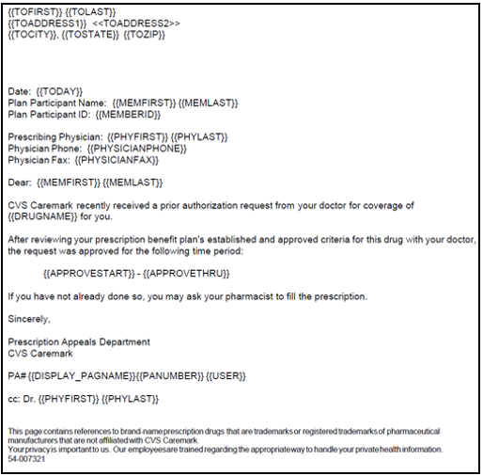

**Approval Member Letter Sample**

[Top of the Document](#_top)

|  |
| --- |
| Standard Appeal Denial Member Letter Sample |

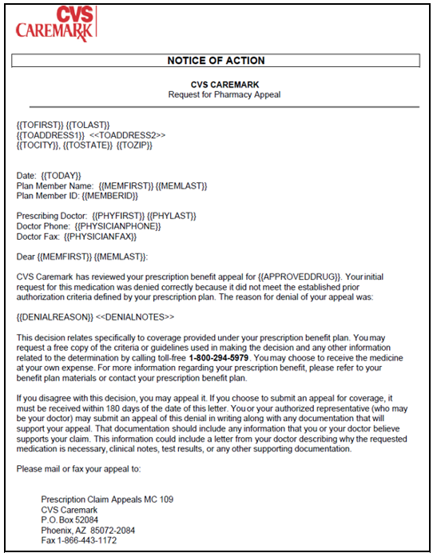

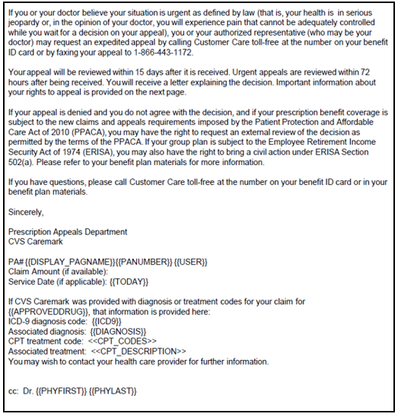

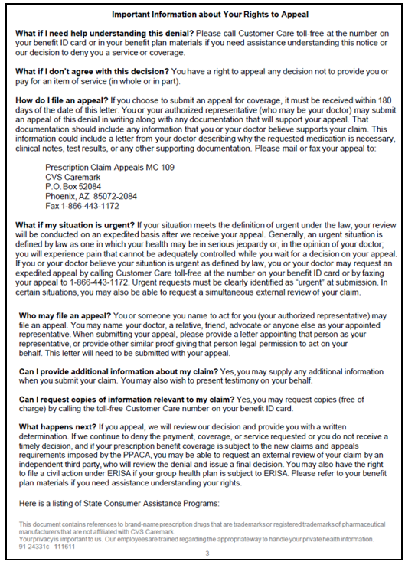

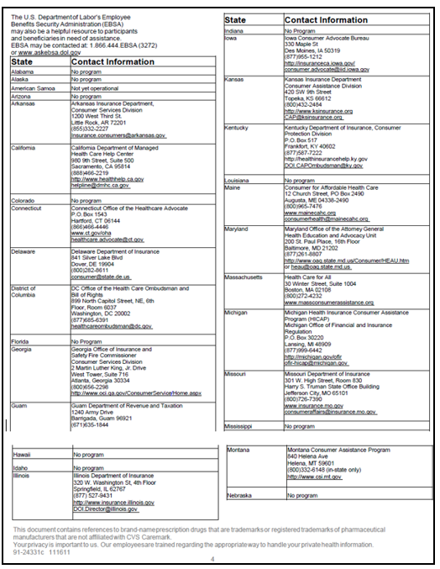

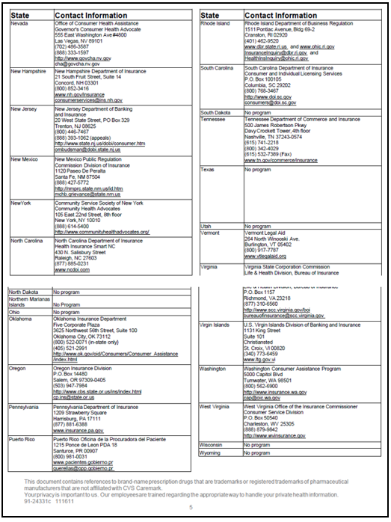

[Top of the Document](#_top)

|  |
| --- |
| Related Documents |

[Log Activity/Capture Activity Codes (005164)](https://thesource.cvshealth.com/nuxeo/thesource/#!/view?docid=bdac0c67-5fee-47ba-a3aa-aab84900cf78)

[Customer Care Abbreviations, Definitions, and Terms Index (017428)](https://thesource.cvshealth.com/nuxeo/thesource/#!/view?docid=c1f1028b-e42c-4b4f-a4cf-cc0b42c91606)

[Prior Authorization, Exceptions, Appeals Guide (063978)](https://thesource.cvshealth.com/nuxeo/thesource/#!/view?docid=657ddfe3-27d1-4a21-8f51-8cbd3961001c)

[MED D - Coverage Determinations and Redeterminations (Appeals) Landing Page (004825)](https://thesource.cvshealth.com/nuxeo/thesource/" \l "!/view?docid=1e7d7ad7-e1c1-4fa1-8258-215a1c0ff32b)

[Test Claim (004573)](https://thesource.cvshealth.com/nuxeo/thesource/#!/view?docid=59c4e7fa-4a87-43c4-89cd-5d4f8c6c3421)

**Parent Document:** [CALL 0049 Customer Care Internal and External Call Handling](https://policy.corp.cvscaremark.com/pnp/faces/DocRenderer?documentId=CALL-0049)

[Top of the Document](#_top)

Not to Be Reproduced or Disclosed to Others without Prior Written Approval

**ELECTRONIC DATA = OFFICIAL VERSION / PAPER COPY = INFORMATIONAL ONLY**